Lab Perform

Step 1: Branch Creation

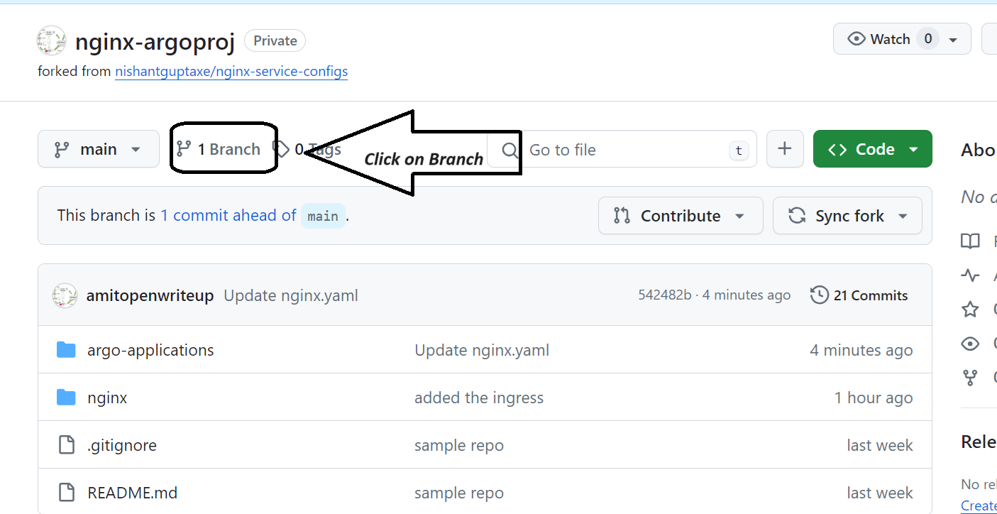

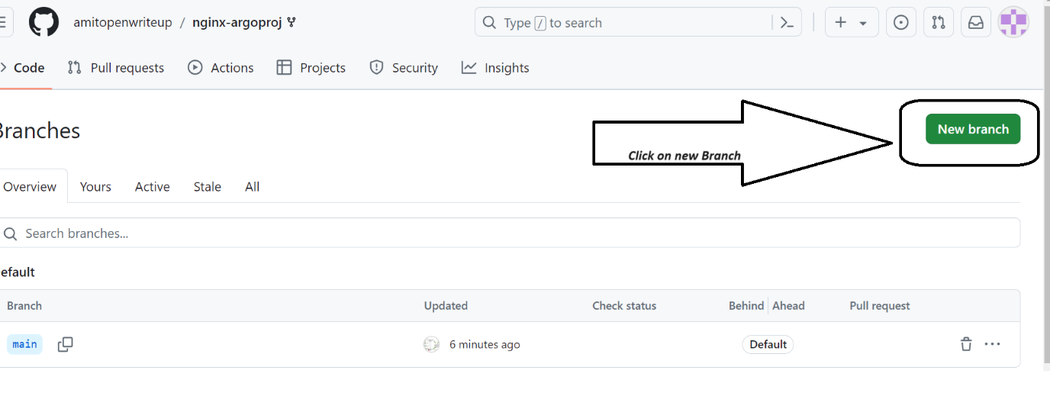

**Provide your username** and create branch

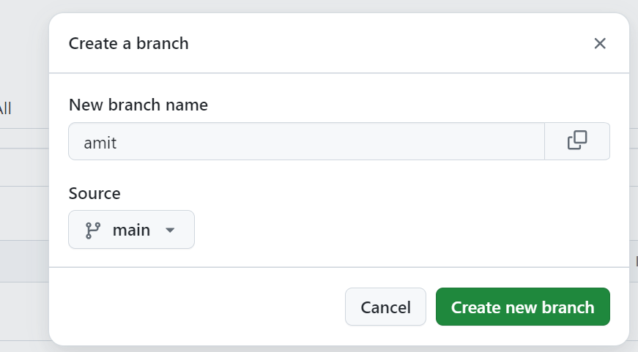

Step 2: Click on the branch

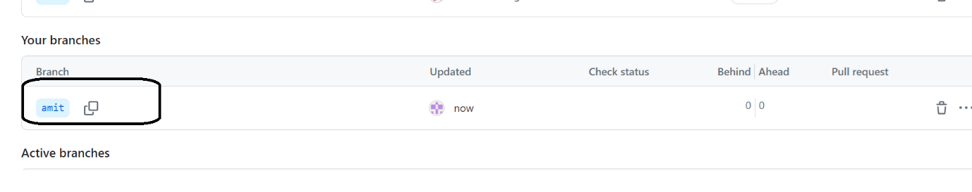

Go in the nginx folder

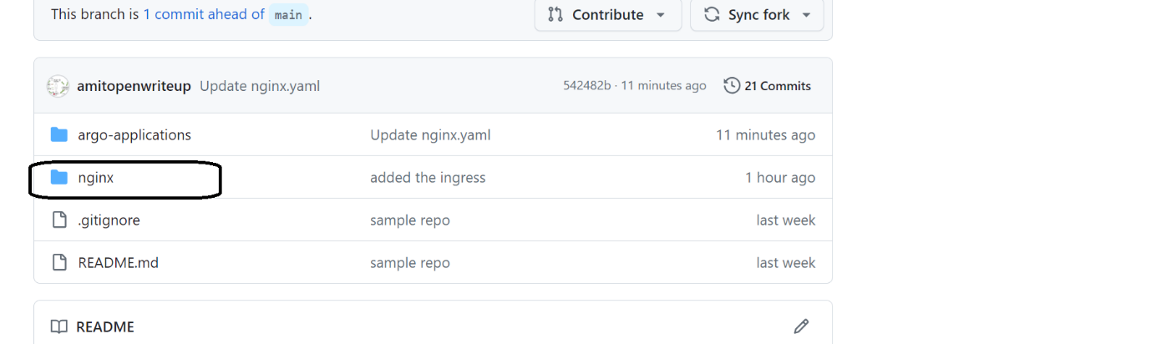

Under templates

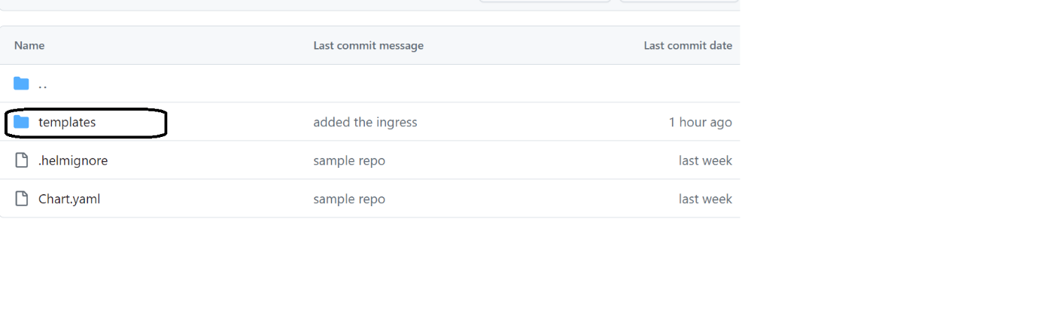

Step 3: All the yaml files available

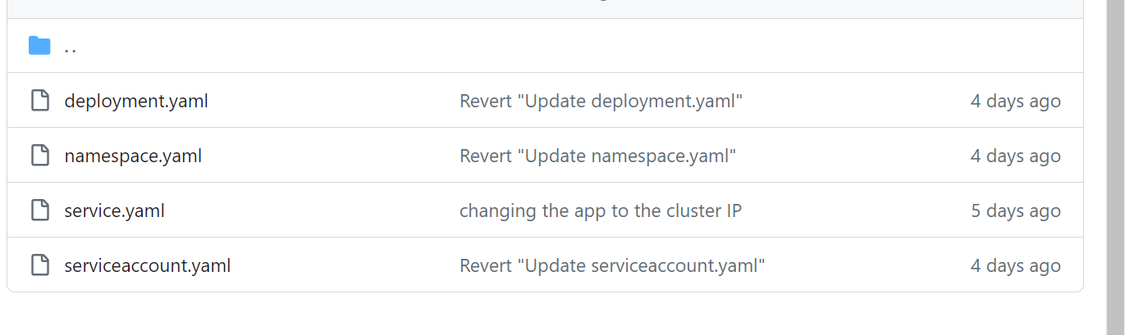

Step 4: Modify the yaml files

* Namespace and service account

Start from namespace.yaml🡪Click on that file

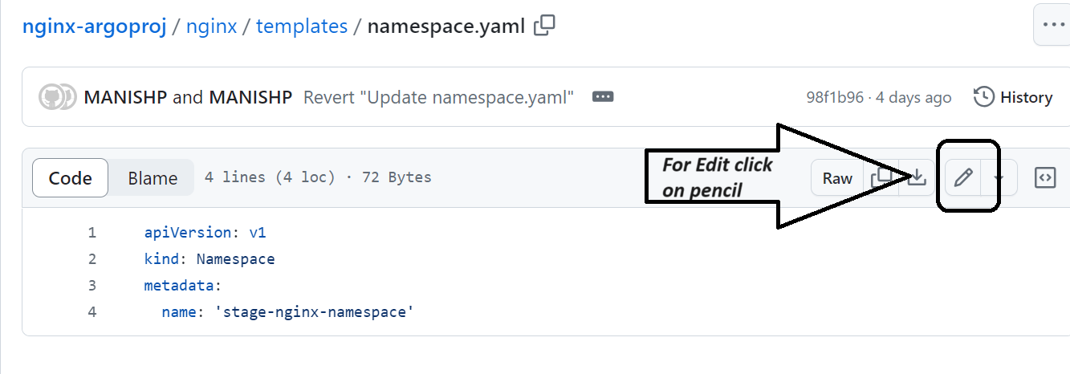

**Modify the namespace name, please enter your username followed by <username>-stage-nginx-namepsace:**

apiVersion: v1

kind: Namespace

metadata:

name: 'amit-stage-nginx-namespace'

**Commit the changes**

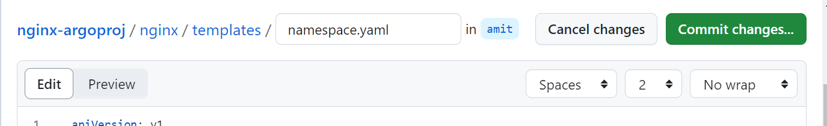

**Step 5: Same way modify Service Account , name and namespace**

**apiVersion: v1**

**kind: ServiceAccount**

**metadata:**

**annotations:**

**eks.amazonaws.com/role-arn: arn:aws:iam::130705418859:role/stage-nginx-sa-role**

**name: amit-stage-nginx-sa**

**namespace: amit-stage-nginx-namespace**

**Step6: Add namespace in service.yaml and commit**

**apiVersion: v1**

**kind: Service**

**metadata:**

**name: nginx**

**namespace: amit-stage-nginx-namespace**

**spec:**

**type: ClusterIP**

**ports:**

**- port: 80**

**protocol: TCP**

**targetPort: 80**

**name: http**

**selector:**

**app.kubernetes.io/name: external-app**

**app.kubernetes.io/instance: nginx**

**Step7**

**Modify deployment.yaml, modify the namespace and service account**

**apiVersion: apps/v1**

**kind: Deployment**

**metadata:**

**name: nginx**

**namespace: amit-stage-nginx-namespace**

**labels:**

**app: nginx**

**company: devseccops**

**spec:**

**replicas: 1**

**selector:**

**matchLabels:**

**app.kubernetes.io/name: external-app**

**app.kubernetes.io/instance: nginx**

**template:**

**metadata:**

**labels:**

**app.kubernetes.io/name: external-app**

**app.kubernetes.io/instance: nginx**

**spec:**

**serviceAccountName: amit-stage-nginx-sa**

**securityContext: {}**

**containers:**

**- name: nginx**

**securityContext: {}**

**image: nginx:latest**

**imagePullPolicy: 'Always'**

**env:**

**- name: "ENVIRONMENT"**

**value: stage**

**resources:**

**requests:**

**memory: '256Mi'**

**cpu: '200m'**

**limits:**

**memory: '256Mi'**

**cpu: '200m'**

**ports:**

**- containerPort: 80**

**name: http**

**protocol: TCP**

**livenessProbe:**

**httpGet:**

**path: /**

**port: http**

**initialDelaySeconds: 10**

**periodSeconds: 10**

**readinessProbe:**

**httpGet:**

**path: /**

**port: http**

**initialDelaySeconds: 10**

**periodSeconds: 10**